

**SNAG@JOB**

CS551 ASE Project Increment2 Report



March 18, 2015

UNIVERSITY OF MISSOURI-KANSAS CITY

CS551 ASE Project SP15

By

Surekha Dani-ID#12

Srikar Reddy Mallareddygari-ID#33

Lavanya Kumar Somu-ID#46

Sandesh Puppala-ID#42

Table of Contents

[Import Existing Services/API 2](#_Toc412670725)

[Detail Design of Services 4](#_Toc412670726)

[User Stories /Use Case (Using Scrum Do) 4](#_Toc412670727)

[Service description 7](#_Toc412670728)

[Sequence diagram 9](#_Toc412670729)

[Sequence Diagram Description 9](#_Toc412670730)

[Class diagram 10](#_Toc412670731)

[Class Diagram Description 11](#_Toc412670732)

[Design of Mobile Client Interface 12](#_Toc412670733)

[Implementation 13](#_Toc412670734)

[Implementation of REST services 13](#_Toc412670735)

[Implementation of user interface (Mobile Apps) 16](#_Toc412670736)

[Project Management 19](#_Toc412670737)

[Work completed 19](#_Toc412670738)

[Description 19](#_Toc412670739)

[Responsibility (Task, Person) 19](#_Toc412670740)

[Time taken 19](#_Toc412670741)

[Contributions (members/percentage) 19](#_Toc412670742)

[Work to be completed 19](#_Toc412670743)

[Description 19](#_Toc412670744)

[Responsibility (Task, Person) 20](#_Toc412670745)

[Time to be taken 20](#_Toc412670746)

[Scrum Do Link 20](#_Toc412670747)

[Summary 20](#_Toc412670748)

[Iteration1 20](#_Toc412670749)

[GitHub Link 20](#_Toc412670750)

[Source Code 20](#_Toc412670751)

[Documentation 20](#_Toc412670752)

[Issues/Concerns 20](#_Toc412670753)

[References 21](#_Toc412670754)

# Import Existing Services/API

**Screenshots for Google API integration**

* OAuth Access Application Access for Google+ Sign In

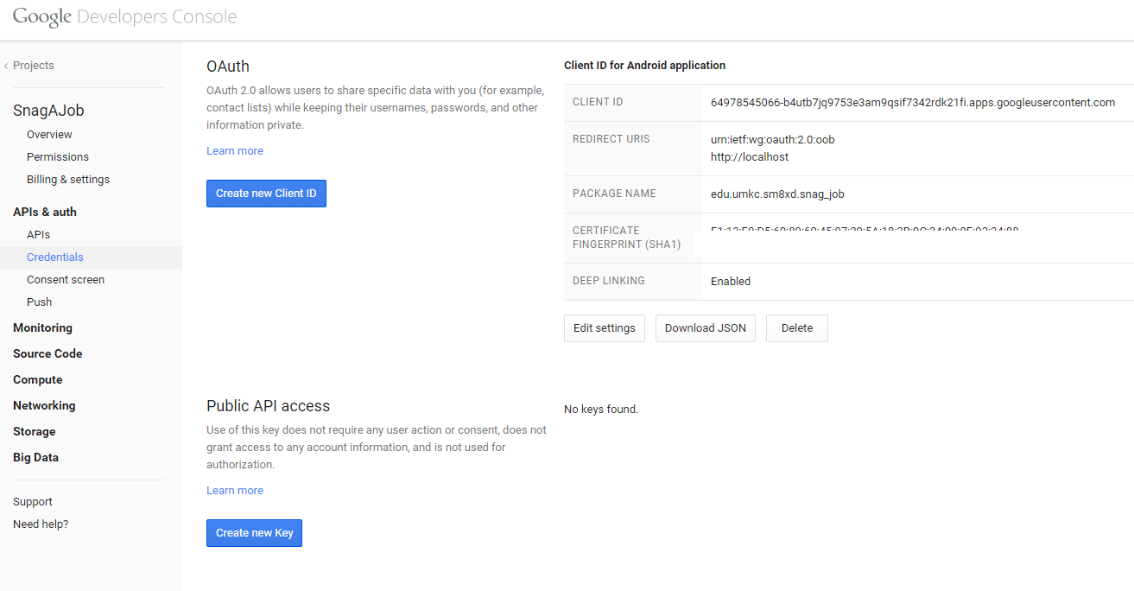

* Google Sign In Validation for Mobile App

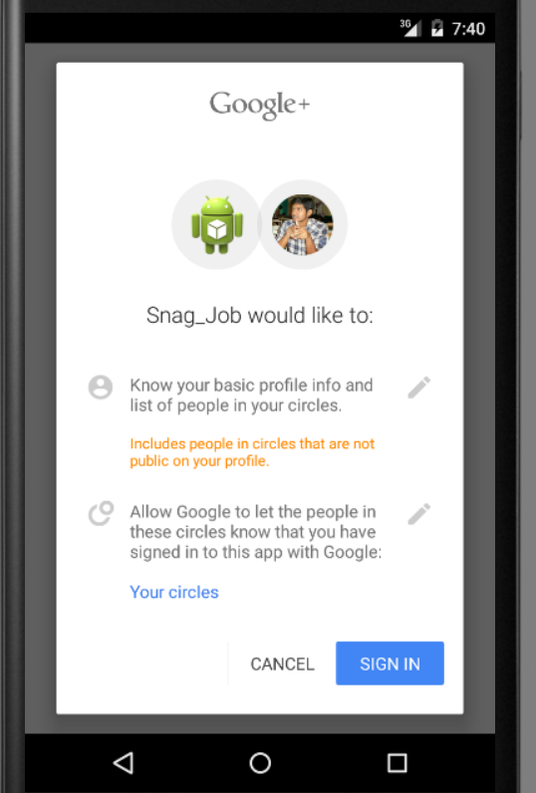

Screenshots of LinkedIn SignIn Integration

* App Registration

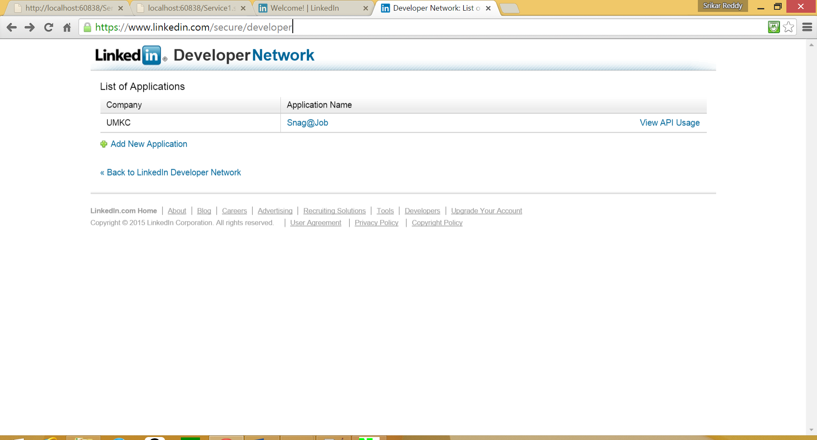

* Retrieving Details from User SignIn

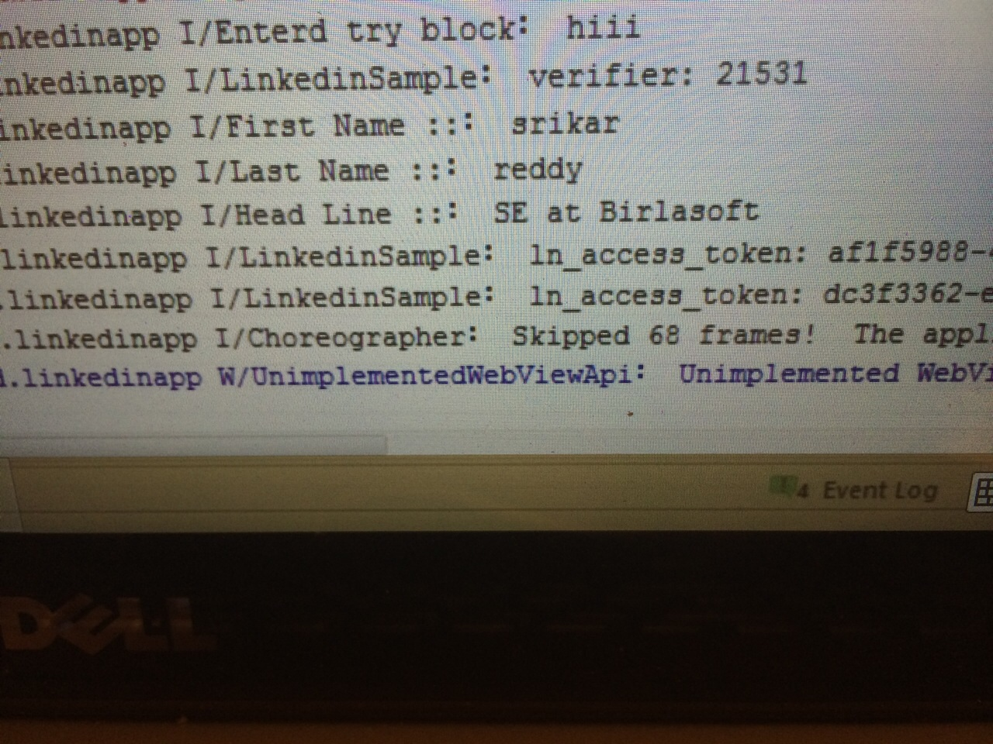

* Login Activity Class from Android Studio

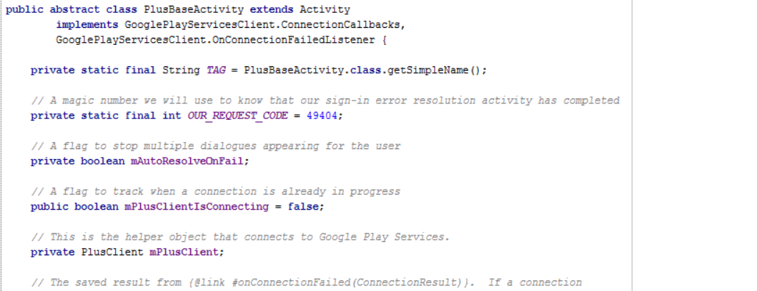

# Detail Design of Services

## User Stories /Use Case (Using Scrum Do)

## Scrum Board:

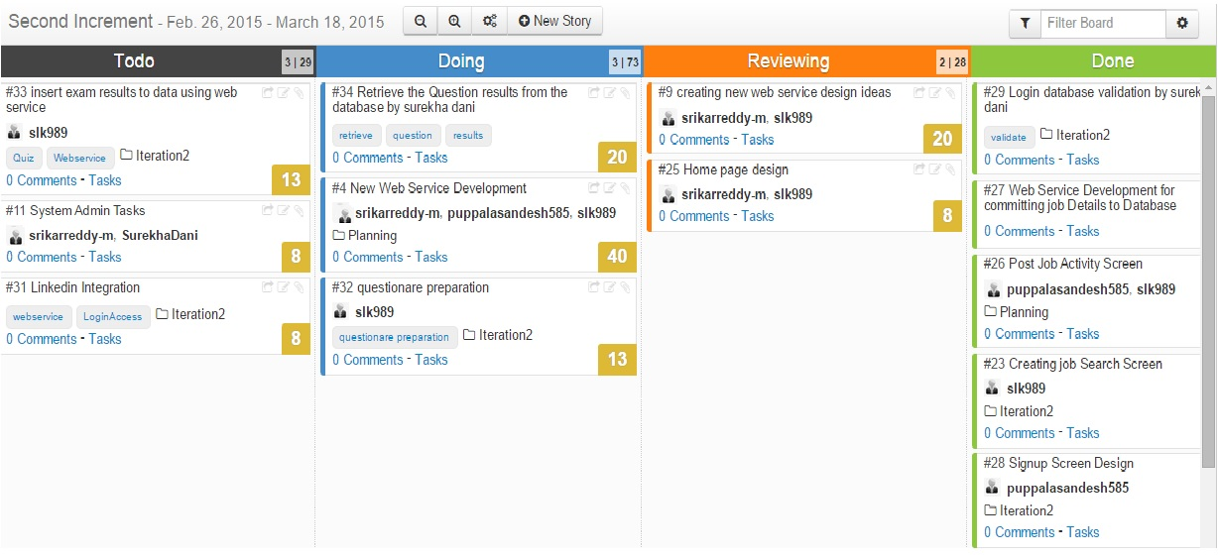

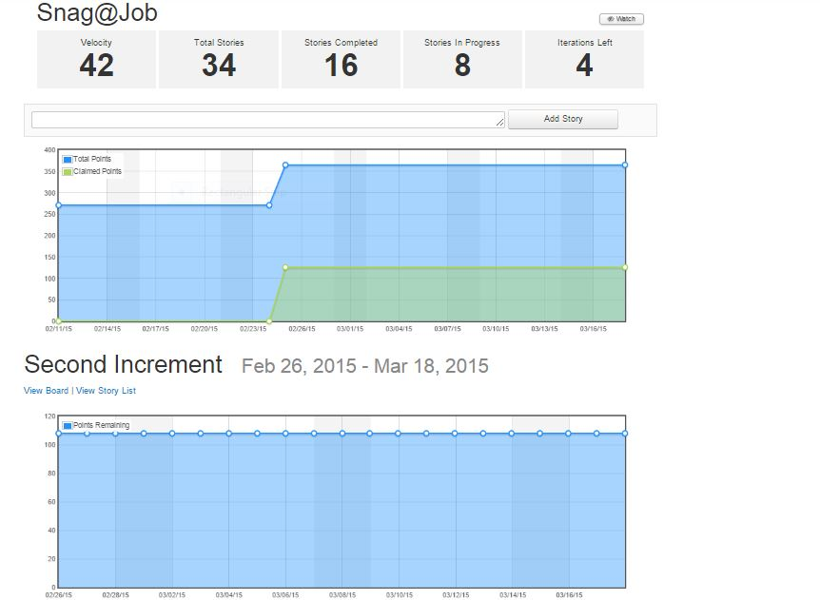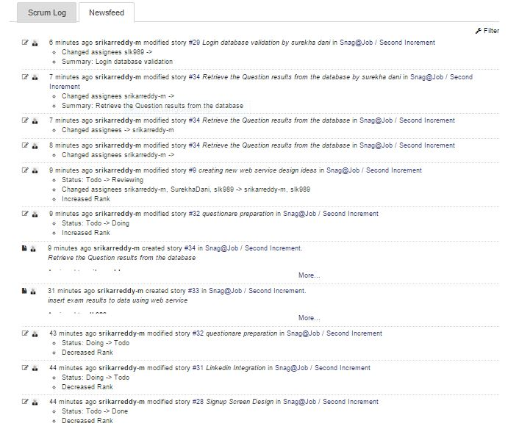

## 

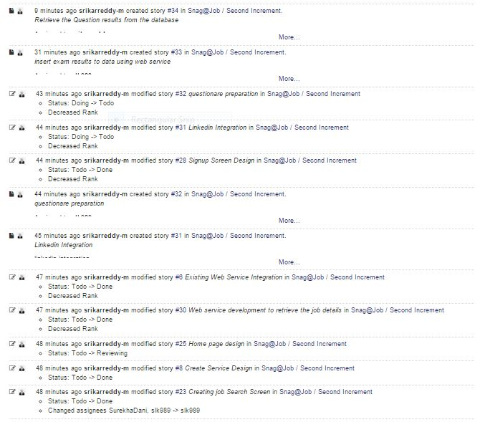

## Service description

* **Snag job Web service:** A REST Web service is created Using Microsoft Visual Studio. It consists of two namely
  + - **insertUserDetails**
    - **retrieveUserDetails**
    - **insertJobDetails**
    - **retrieveJobDetails**

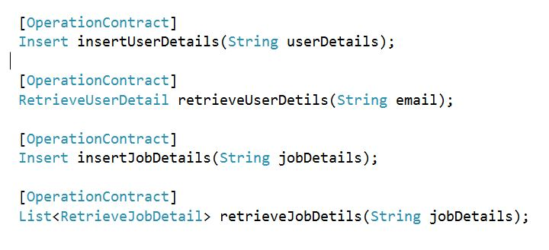

These two methods are useful to perform user registration and user login activities on a mobile application.

*InsertUserDetails:* This method performs storing of the user profile details to the MySQL server 2008 database.

*RetrieveUserDetails:* This method is useful to retrieve the user profile details after successful validation of login credentials.

These two methods are useful to insert and retrieve job details as discussed below.

*InsertJobDetails:* This method is useful to insert the job details in to the mysql server.

*retrieveJobDetails:* This method is useful to retrieve the job details based on the search criteria.

## Sequence diagram

**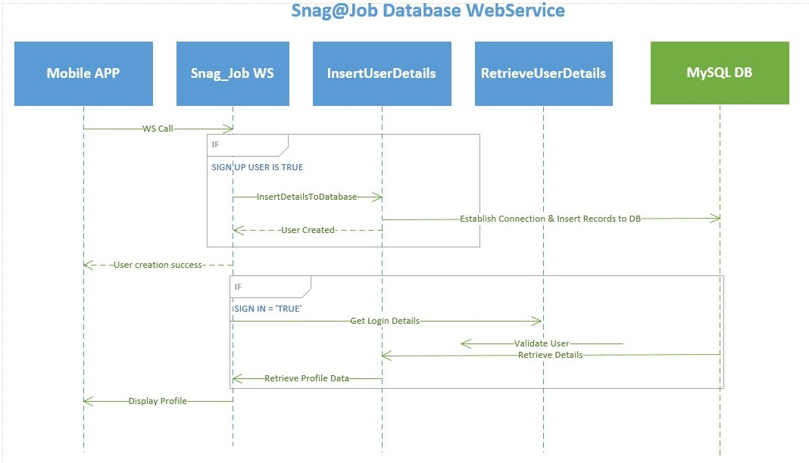**

## Sequence Diagram Description

* A Web service named Snag\_Job is developed to perform a user’s registration and retrieval of the users profile data.
* When a user tries to Sign up in to the mobile application, the user details will be stored in to the MySQL DB using a Web service call.

<http://localhost:60838/Service1.svc/insertUserDetails/>

* When user tries to login in to the application, User credentials are authenticated through a Web service call. For authenticated users corresponding profile data will be displayed to the presentation layer of the mobile application.
* When employer logins into the app, he can post the jobdetails for a particular job.This is accomplished by call the insertJobDetails web service.

<http://localhost:60838/Service1.svc/insertJobDetails/>

* When applicant logins into the app and tries to apply for any job,the list available jobs are retrieved from the database by calling the retrieveJobDetails service

[http://localhost:60838/Service1.svc/retrievelogin/](http://localhost:60838/Service1.svc/retrievelogin/dani)

## D:\ASE\Class Diagram_Cropped.jpgClass diagram



## Class Diagram Description

* As shown in the above class diagram, we have implemented three different classes namely UserDetailsActivity, LoginDetailsActivity, SnagJobService.
* UserDetailsActivity class consists of various fields like first Name, last Name, phone, address, state, city and zip code along with their getter and setter methods.
* LoginDetailsActivity class consists fields email, password long with setter and getter methods.
* SnagJobService class contains two different methods of which once is responsible for insertion of user details while the other one is useful for the retrieval of details.
* PostJobDetailsActivity class consists of the job details to be stored into the database whenever employer post any job.
* ViewPostedJobsActivity class is used to retrieve the job details from the database when the employer wishes to view/edit the jobs he posted.

# Design of Mobile Client Interface

**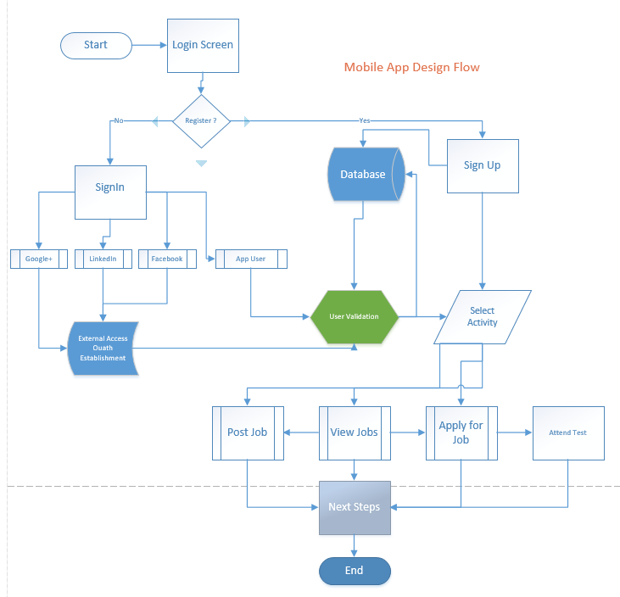**

# Implementation

## Implementation of REST services

* Web Service Call for insertuserdetails:

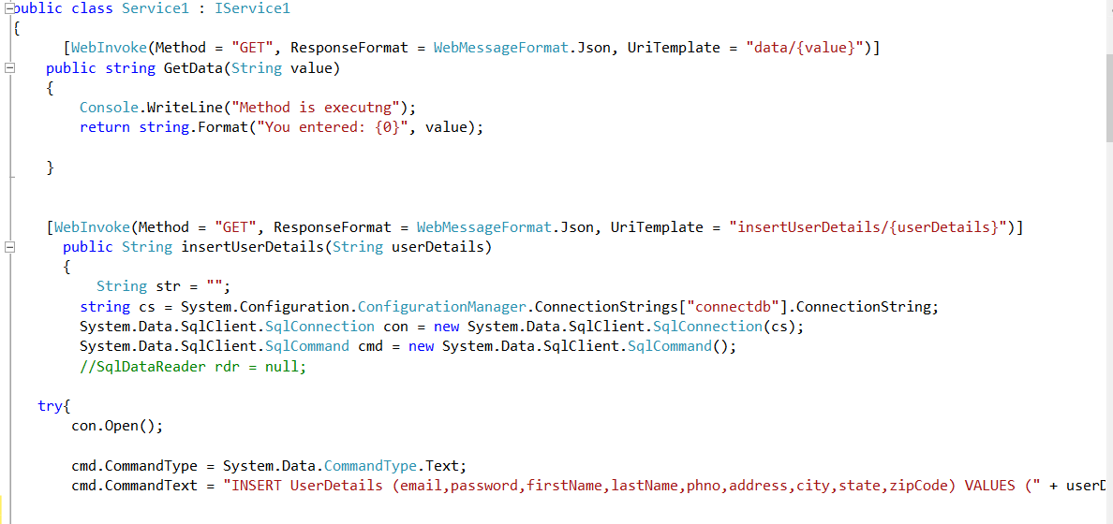

* Web Service Call for retrieveuserdetails

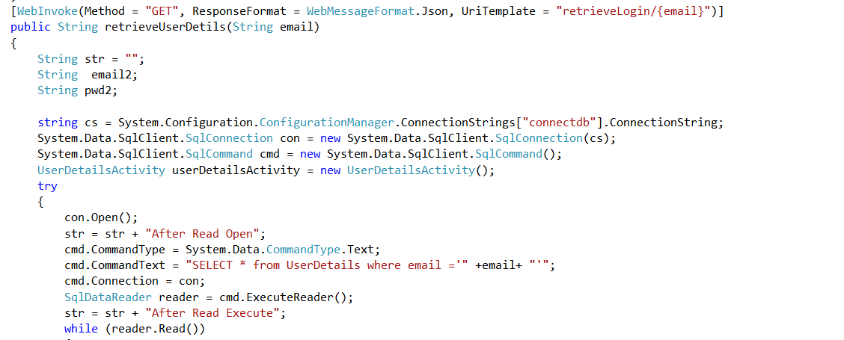

* Web Service Call for insertjobdetails

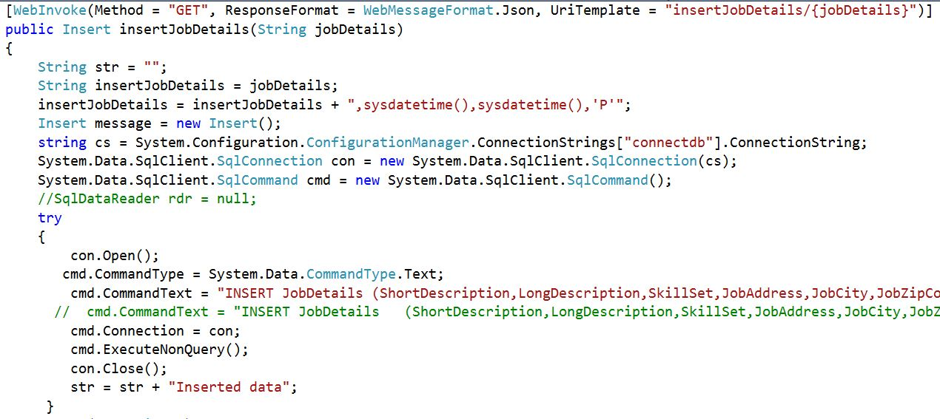

* Web Service Call for retrievejobdetails

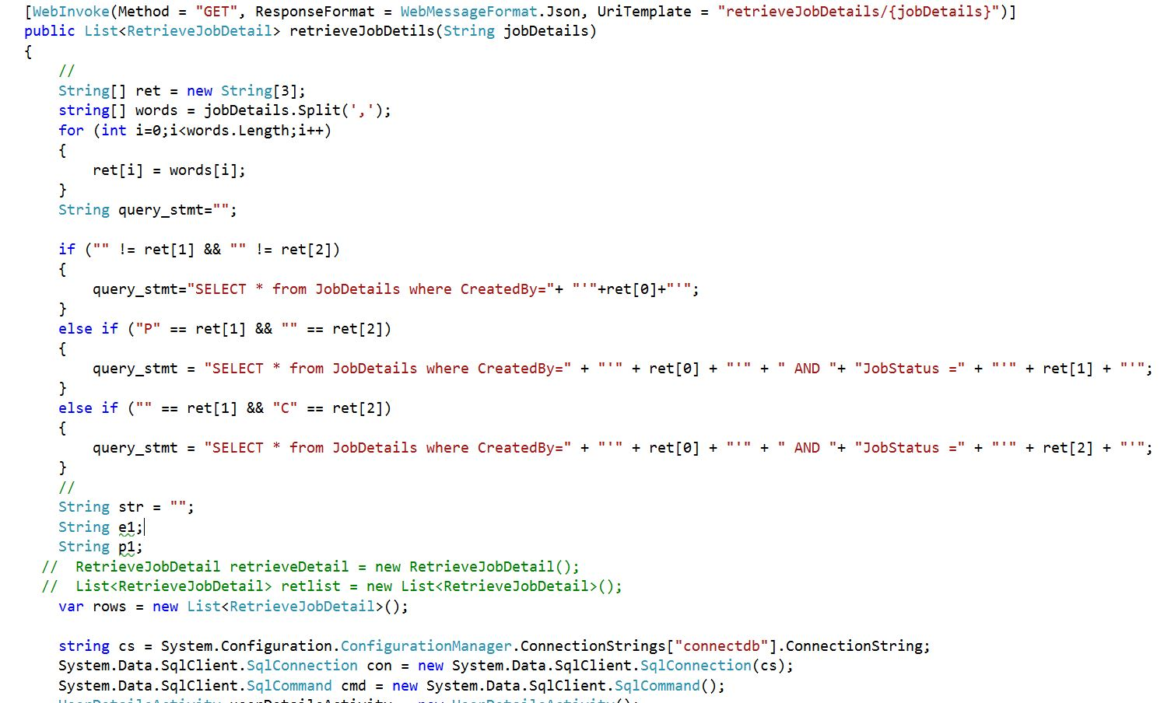

* Database Table Data Definition
  + Login Details Table:

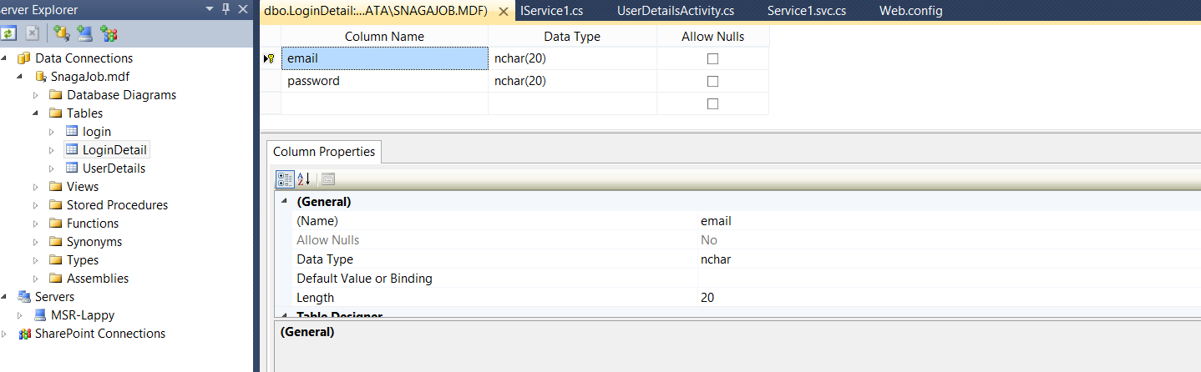

* + User Details Table:

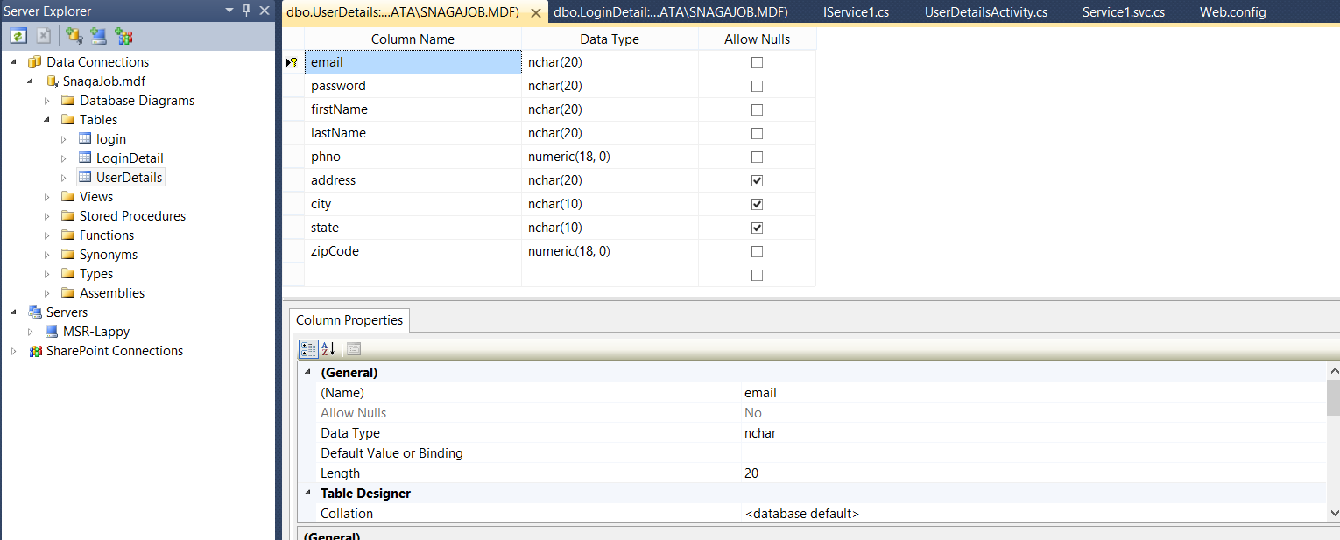

* + Job Details Table:

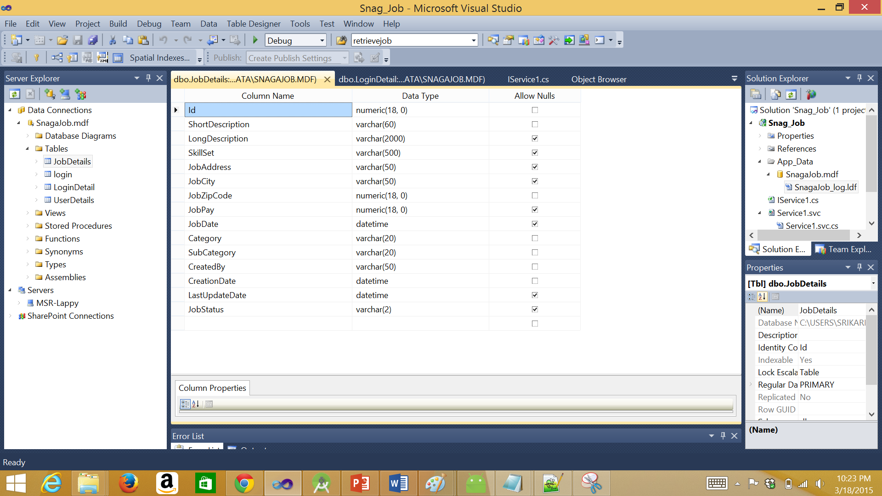

## Implementation of user interface (Mobile Apps)

* Login Activity:



* This is the login screen of the mobile application.
* A user can sign in to the application using the google+ sign in, general sign in and a new user can sign up.
* A user require an email id and password to login to the application

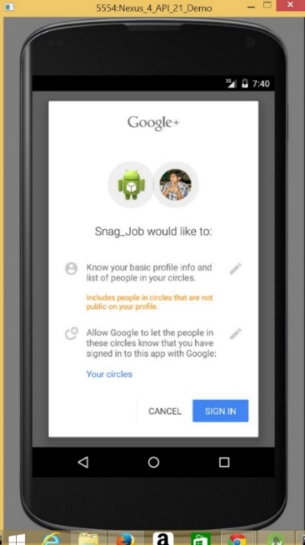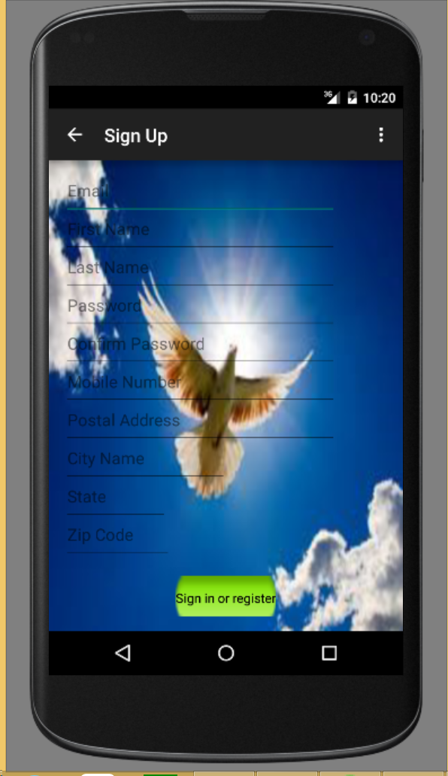

Sign in with google+ sign in tab.

Sign up Screen of the User.

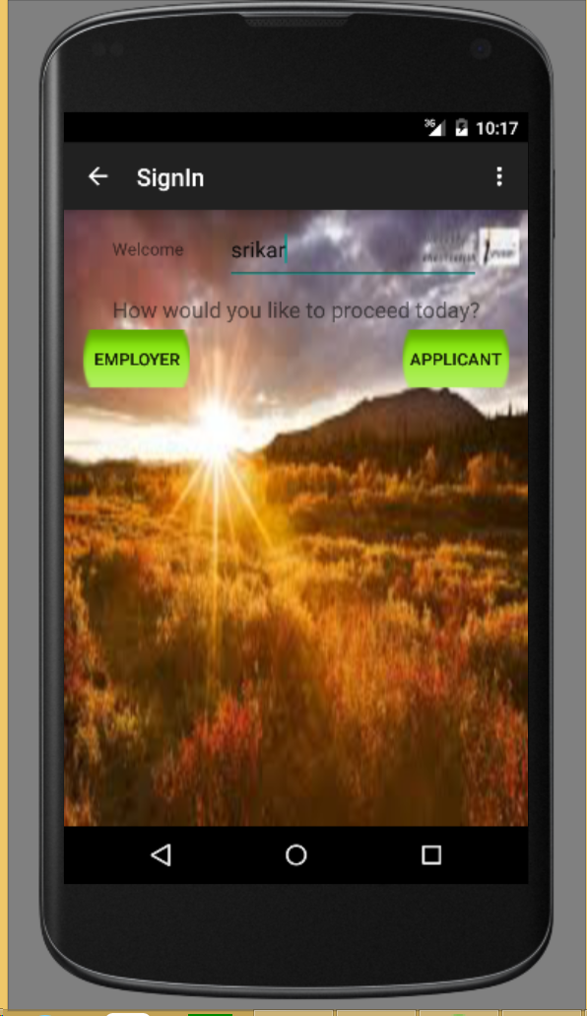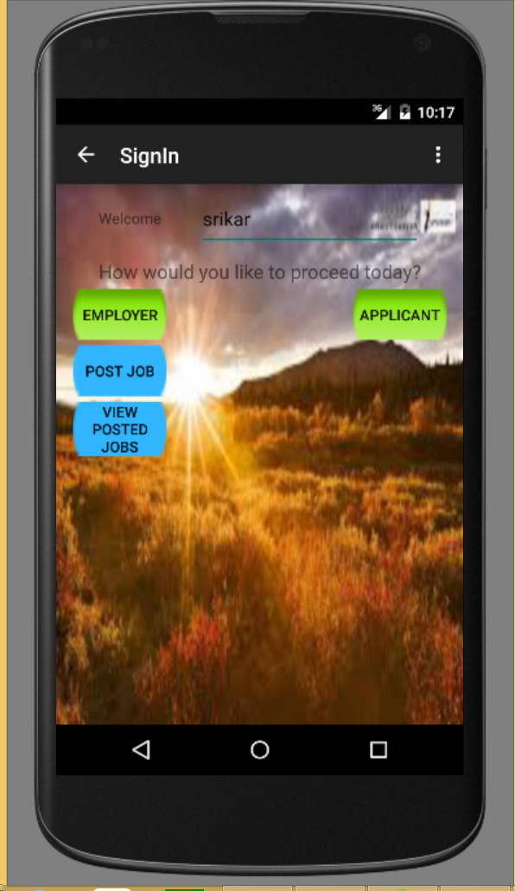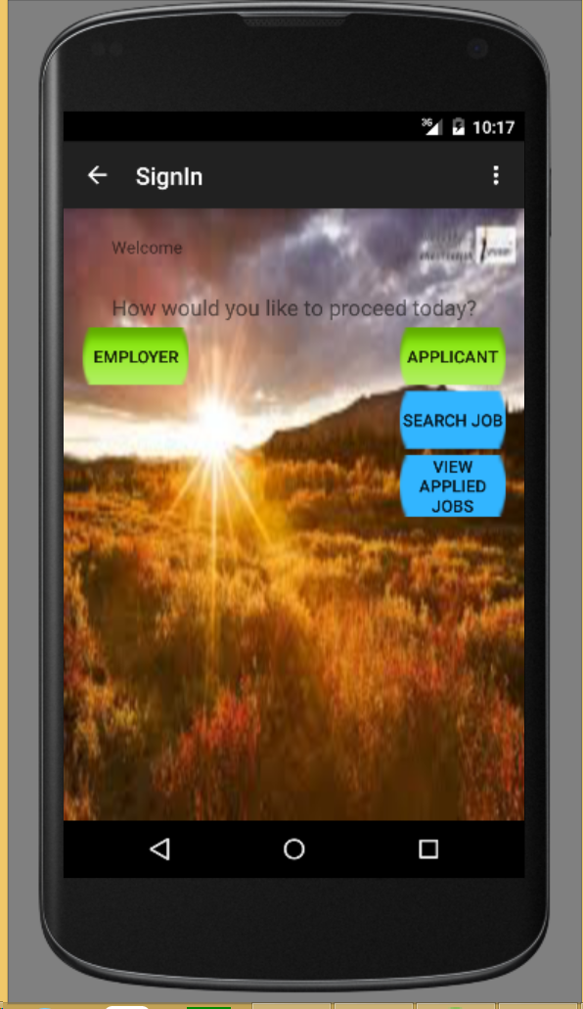

Home Page- Sign in Screen

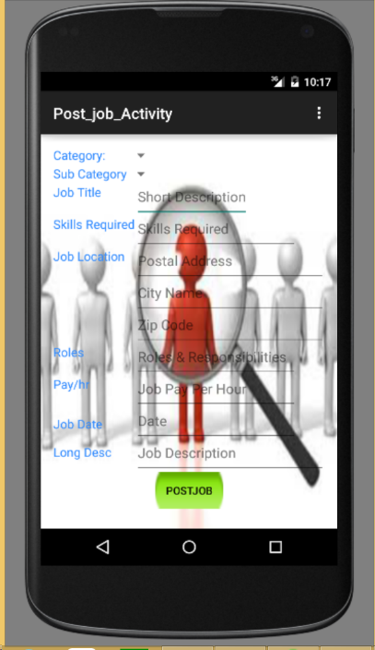 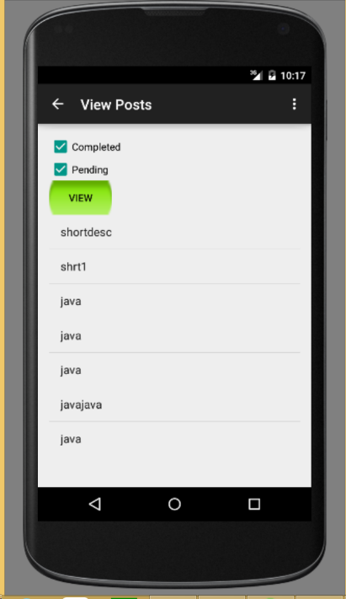

Post Job Screen

View Posted Jobs Screen



Search Jobs Screen

## Implementation of test cases

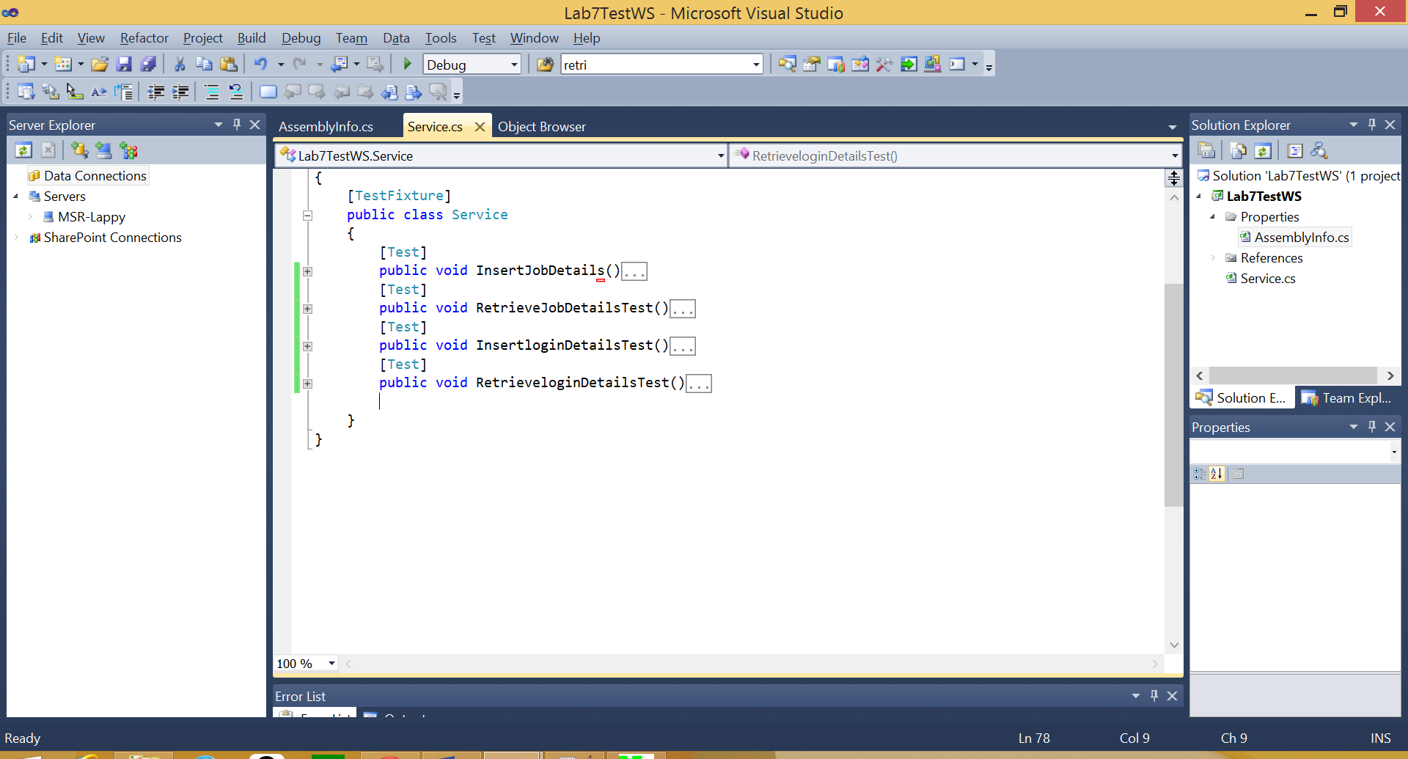

InsertJobDetails WebService:

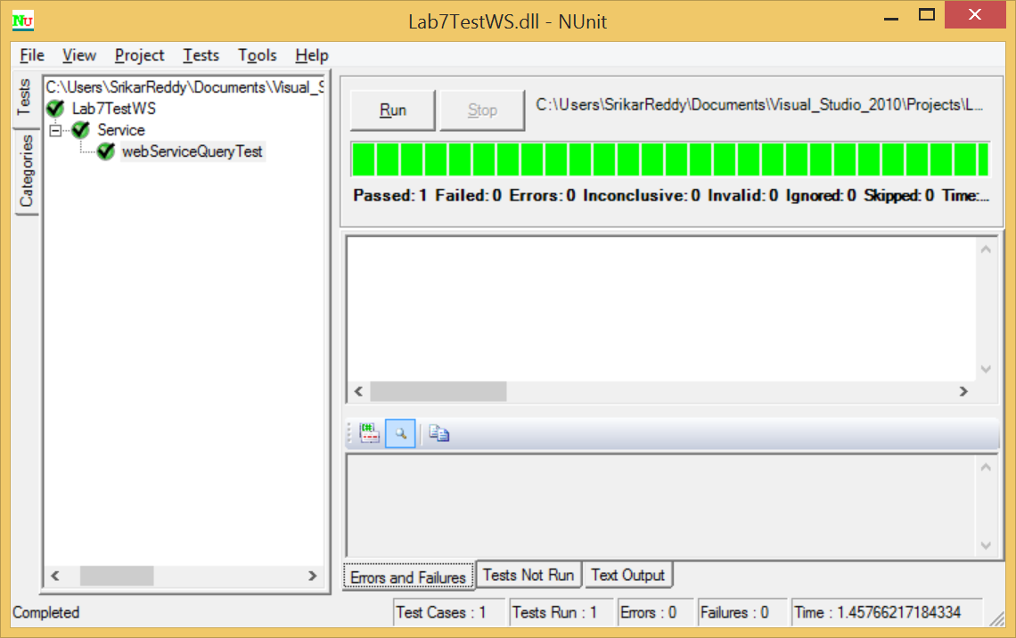

RetrieveJobDetails WebService:



InsertLoginDetails WebService:



RetrieveLoginDetails Web Service:



Project Management

## Work completed

### Description

* Successfully created a REST Web service which is useful for the insertion and retrieval of users profile data over Webservice calls.
* Successfully created database tables using Microsoft Visual Studio.
* Successfully developed the Login Screen, Signup Screen and Post job User Interfaces.
* Successfully created REST Web service for Posting a Job Details from android to SQL DB
* Successfully implemented REST Web Service for Retrieval of Posted Jobs by an employer into list view of android screen
* Designed a layout for Search Jobs Page.
* LinkedIn Profile SignIn is implemented separately for User Sign in.

### Responsibility (Task, Person)

* InsertJobDetails WS, InsertUserDetails WS, DDL for Jobs, Signup Page Layout, InsertJobDetails WS Unit testing, Google App– Srikar Reddy Mallareddygari
* Post Job Layout, Layout Backgrounds for Activities, Layout Coloring, Documentation, InsertUserDetails WS Unit testing – Lavanya Kumar Somu
* Home Page Layout, Home Page Button logic ,Search Job Activity List View, RetrieveJobDetails WS, RetrieveUserDetails WS RetrieveJobDetails WS Unit testing, LinkedIn App – Surekha Dani
* Sign In Page Layout, Search Job Layout, Database Table Definitions for Users, RetrieveUserDetails WS Unit testing, Documentation– Sandesh Puppala

### Time taken

200 Man Hours

### Contributions (members/percentage)

Srikar Reddy Mallareddygari – 25%

Lavanya Kumar Somu - 25%

Surekha Dani - 25%

Sandesh Puppala – 25%

## Work to be completed

### Description

Task1: Integrating LinkedIn App.

Task2: View Applied Jobs by applicant Screen Design & backend Logic

Task3: Develop Questionnaire, Develop screens to conduct exam, Retrieve exam questions based on selected technical job criteria.

Task 4: Evaluate the exam, Display and store the results in database.

### Responsibility (Task, Person)

Task 1: Surekha Dani

Task 2: Lavanya Kumar Somu

Task 3: Srikar Reddy Mallareddygari

Task 4: Sandesh Puppala

### Time to be taken

300 Man Hours

# Scrum Do Link

## Summary

<https://www.scrumdo.com/projects/project/snagjob1/summary>

## Iteration2

<https://www.scrumdo.com/projects/project/snagjob1/iteration/121720/board>

# GitHub Link

## Source Code

<https://github.com/srikarreddy-m/CS551-ASE/tree/src/Project/Snag%40Job/src/Iteration2/Snag_Job>

## Documentation

<https://github.com/srikarreddy-m/CS551-ASE/tree/src/Project/Snag%40Job/documentation>

# Issues/Concerns

* Large android project for Mobile deployment
* Slow performance of the web service call